

|  |  |  |
| --- | --- | --- |
| Class :**III/IVB.Tech** | **Assignment-I** | Date : 28-11-2020 |
| Branch **: ECE** | **LINEAR CONTROL SYSTEMS** |  |
| Sub Code : **EC-311** |  | Max.Marks :**12** |

1. Derive the transfer function and block diagram for speed control of DC servo motor?. (**Create**)
2. Obtain the transfer function of the closed loop control system shown in fig. using the block body reduction technique. **(Apply)**

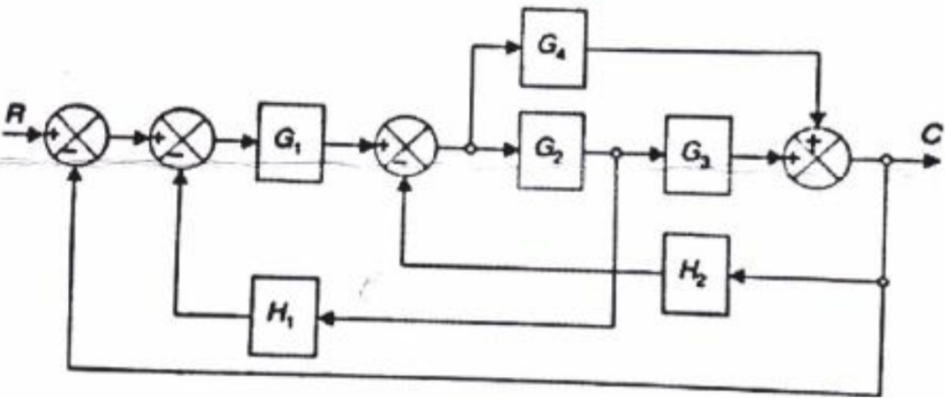

1. Find the transfer function of the signal flow graph shown in fig. using the mason’s gain formula. **(Apply)**

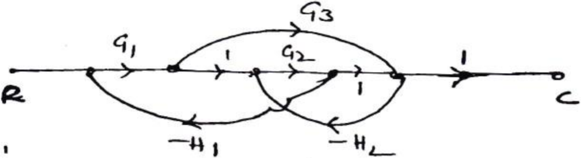

1. Derive the expression for peak, rise time in terms of ξ and ωn for a second order control system. (**Create)**
2. A unity feedback system is characterized by a open loop transfer function. **(Apply)**

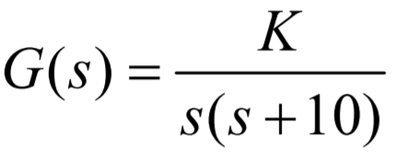

Determine the gain K so that the system will have a damping ratio of 0.5. For this value of K determine settling time, peak overshoot, and time to peak overshoot for unit step input.

1. Find all steady state errors for open loop transfer function with unity feed back given by

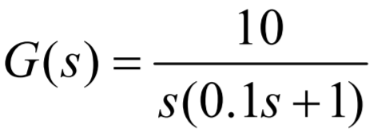 **(Apply)**